**OUT PATIENT DEPARTMENT (OPD)**

**REPORT**

**TEAM MEMBERS**

BALNE NITEESHA – 18114017

KARANPREET SINGH – 18114036

LESHNA BALARA – 18114044

PRIYANSH AGARWAL – 18114057

RADHIKA GARG – 18114060

**ABSTRACT (Problem Statement)**

Generally, OPD is designed for the treatment of outpatients, the people with health issues who come for diagnosis but are not meant to be admitted for overnight care. Modern outpatient departments offer a wide range of treatment services, diagnostic tests and minor surgical procedures.

While considering the viewpoint of patients, their personal details and required diagnosis information is registered. The patients are informed about the consultant medical practitioner and fees. The basic information of hospital which includes its name, address and contact number are to be mentioned and made available to both outpatients and staff (indicating it as the main class).

The staff of the hospital includes doctors, nurses and cleaning staff. Each of them having their identities and salaries. The directors and receptionist are involved in the administration, who have the information of how things are working

The directors, receptionist and doctors have an access to the portal which has patients’ information. The directors can remove or add staff and modify the salaries and fees. The receptionist registers the personal details of the patient, directs them to the doctor and adds their fees into the portal. The doctor writes the required diagnosis information of the patient.

Laboratories and pharmacy facilities are available. Tests that are required for the diagnosis, for example, blood test, sugar test, X ray facility etc., are performed in the labs. Pharmacy has the regular monitorization of the medicines available in the stock.

**INDEX**

1. Introduction
2. Requirements specification
3. Analysis
4. Design
5. System implementation
6. Testing
7. Sample screenshots
8. Conclusion

**1.INTRODUCTION**

The project Out Patient Department includes registration of patients, storing their details into the system, and also computerized billing in the pharmacy, and labs. The software has the facility to give a unique id for every patient and stores the details of every patient and the staff automatically.

The OPD can be entered using a username and password. It is accessible by administrator: director and receptionist, staff: doctor. Only administrators can add or remove data into the database. The data can be retrieved easily. Without login access, patients can see working hours, doctors’ info and emergency contact numbers. The interface is very user-friendly. The data are well protected for personal use and makes the data processing very fast.

OPD is powerful, flexible, and easy to use and is designed and developed to deliver real conceivable benefits to hospitals and can be accessed anywhere around the world through the internet.

OPD is designed for multi-speciality hospitals, to cover a wide range of hospital administration and management processes. It is an integrated end-to-end Hospital Management System that provides relevant information across the hospital to support effective decision making for patient care, hospital administration and critical financial accounting, in a seamless flow.

OPD is a software product suite designed to improve the quality and management of hospital management in the areas of clinical process analysis and activity-based costing. OPD enables you to develop your organization and improve its effectiveness and quality of work. Managing the key processes efficiently is critical to the success of the hospital helps you manage your processes

**1.2 Problem Introduction:**

**Lack of immediate retrievals: -**

The information is very difficult to retrieve and to find particular information like- E.g. - To find out about the patient’s history, the user has to go through various registers. This results in in inconvenience and wastage of time.

**Lack of immediate information storage: -**

The information generated by various transactions takes time and efforts to be stored at right place.

**Lack of Security**

The information stored in the registers have security issues but through portal login using username and password, each and every detail is secured.

**Lack of prompt updating: -**

Various changes to information like patient details are difficult to make as paper work is involved.

**Preparation of accurate and prompt reports: -**

This becomes a difficult task as information is difficult to collect from various register.

**Objectives:-**

1. Recording information about the Patients that come.
2. Recording information related to diagnosis given to Patients.
3. Giving information about hospital resources and emergency services.
4. Accounts statistics are available to the director.
5. Keeping information about medicines available to cure them.
6. Communication among various departments becomes easy.

These are the various jobs that need to be done in a Hospital by the operational staff and Doctors. All these works are traditionally done on papers. OPD intends to computerize all this stuff.

**1.3 MODULES:**

The entire project mainly consists of 6 modules and some further submodules, which are

* Hospital module
* Administration module
* Director module
* Receptionist module
* Staff module
* Doctor module
* Nurse module
* Cleaning Staff module
* Pharmacy module
* Medicine module
* Lab module
* Patient module
* Diagnosis module

**1.3.1 Hospital module:**

* View doctor info
* View emergency numbers and services
* Show working hours
* Give Login access

**1.3.2 Administration module:**

* View doctor info
* View patient info
* View nurse info
* View cleaning staff info
* View pharmacy info
* View lab info
* View cash info
* Set cash info
* Director module:
* Change staff salary
* Remove staff
* Add staff
* Receptionist module:
* Add patient

**1.3.3 Staff module:**

* Doctor module:
* View nurse info
* View patient info
* Write diagnosis for a patient
* Nurse module:
* View patient info
* Cleaning staff module:
* See working hour shift

**1.3.4 Pharmacy module:**

* Can add new medicines
* Can sell medicines
* Medicine module:
* See medicine name
* See medicine stock
* See medicine cost

**1.3.5 Lab module:**

* Perform tests
* Has lab assistant name
* Has lab assistant salary

**1.3.6 Patient module:**

* Stores patient’s details
* Has patient’s diagnosis

**2.REQUIREMENT SPECIFICATION**

Operating System: Linux

Front End: HTML, CSS, JavaScript

Server Side Script: Python, C++

Database: SQLite

**3.ANALYSIS**

**HTML**:

HTML or Hypertext Markup Language is the standard markup language used to create web pages. HTML is written in the form of HTML elements consisting of tags enclosed in angle brackets (like <html>). HTML tags most commonly come in pairs like <h1> and </h1>, although some tags represent empty elements and so are unpaired, for example <img>. The first tag in a pair is the start tag, and the second tag is the end tag(they are also called opening tags and closing tags). Though not always necessary, it is best practice to append a slash to tags which are not paired with a closing tag.

The purpose of a web browser is to read HTML documents and compose them into visible or audible web pages. The browser does not display the HTML tags, but uses the tags to interpret the content of the page. HTML describes the structure of a website semantically along with cues for presentation, making it a markup language rather than a programming language. HTML elements form the building blocks of all websites.

HTML allows images and objects to be embedded and can be used to create interactive forms. It provides a means to create structured documents by denoting structural semantics for text such as headings, paragraphs, lists, links, quotes and other items. It can embed scripts written in languages such as JavaScript which affect the behavior of HTML web pages.

**CASCADING STYLE SHEETS (CSS):**

It is a style sheet language used for describing the look and formatting of a document written in a markup language. While most often used to style web pages and interfaces written in HTML and XHTML, the language can be applied to any kind of XML document, including plain XML, SVG and XUL. CSS is a cornerstone specification of the web and almost all web pages use CSS style sheets to describe their presentation.

CSS is designed primarily to enable the separation of document content from document presentation, including elements such as the layout, colors and fonts. This separation can improve content accessibility, provide more flexibility and control in the specification of presentation characteristics, enable multiple pages to share formatting, and reduce complexity and repetition in the structural content .

CSS can also allow the same markup page to be presented in different styles for different rendering methods, such as on-screen, in print, by voice (when read out by a speech-based browser or screen reader) and on Braille-based, tactile devices. It can also be used to allow the web page to display differently depending on the screen size or device on which it is being viewed. While the author of a document typically links that document to a CSS file, readers can use a different style sheet, perhaps one on their own computer, to override the one the author has specified. However if the author or the reader did not link the document to a specific style sheet the default style of the browser will be applied.

**JAVASCRIPT**:

JavaScript is the scripting language of the Web. All modern HTML pages are using JavaScript.

A scripting language is a lightweight programming language. JavaScript code can be inserted into any HTML page, and it can be executed by all types of web browsers. Uses of JavaScript are:

1. To specify the behavior of web pages.
2. Delete HTML elements.
3. Create new HTML elements.
4. Copy HTML elements.
5. In HTML, JavaScript is a sequence of statements that can be executed by the web browser.

**PYTHON**:

Python is an interpreted, high-level, general-purpose programming language. Python's design philosophy emphasizes code readability with its notable use of significant whitespace. Its language constructs and object-oriented approach aim to help programmers write clear, logical code for small and large-scale projects.

Python is a multi-paradigm programming language. Object-oriented programming and structured programming are fully supported. Many other paradigms are supported via extensions, including design by contract and logic programming.

Python uses dynamic typing, and a combination of reference counting and a cycle-detecting garbage collector for memory management. It also features dynamic name resolution (late binding), which binds method and variable names during program execution.

**C++:**

C++ is a light-weight abstraction programming language [designed] for building and using efficient and elegant abstractions and offering both hardware access and abstraction.

4.DESIGN

# Approach of UML diagrams

**Class Diagram** - Class is a category or group of things that has similar attributes and common behavior. A Rectangle is the icon that represents the class it is divided into three areas. The upper most area contains the name, the middle; area contains the attributes and the lowest areas show the operations. Class diagrams provides the representation that developers work from. Class diagrams help on the analysis side, too.

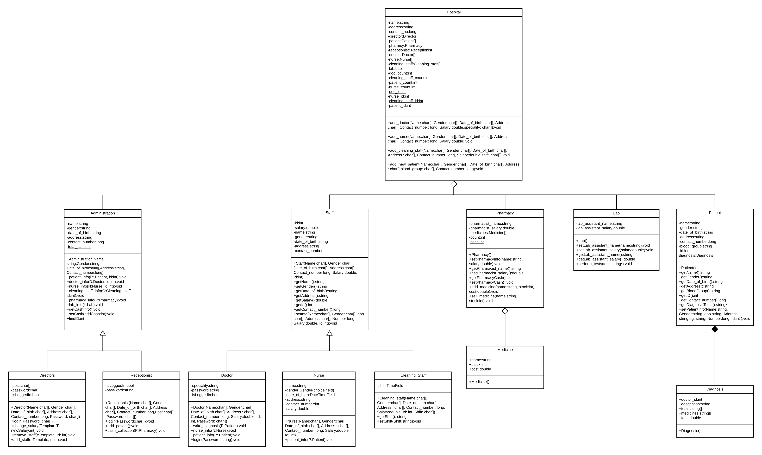

**Use Case Diagram** - A use case diagram in the Unified Modeling Language (UML) is a type of behavioral diagram defined by and created from a use-case analysis. Its purpose is to present a graphical overview of the functionality provided by a system in terms of actors, their goals (represented as use cases),and any dependencies between those use cases.

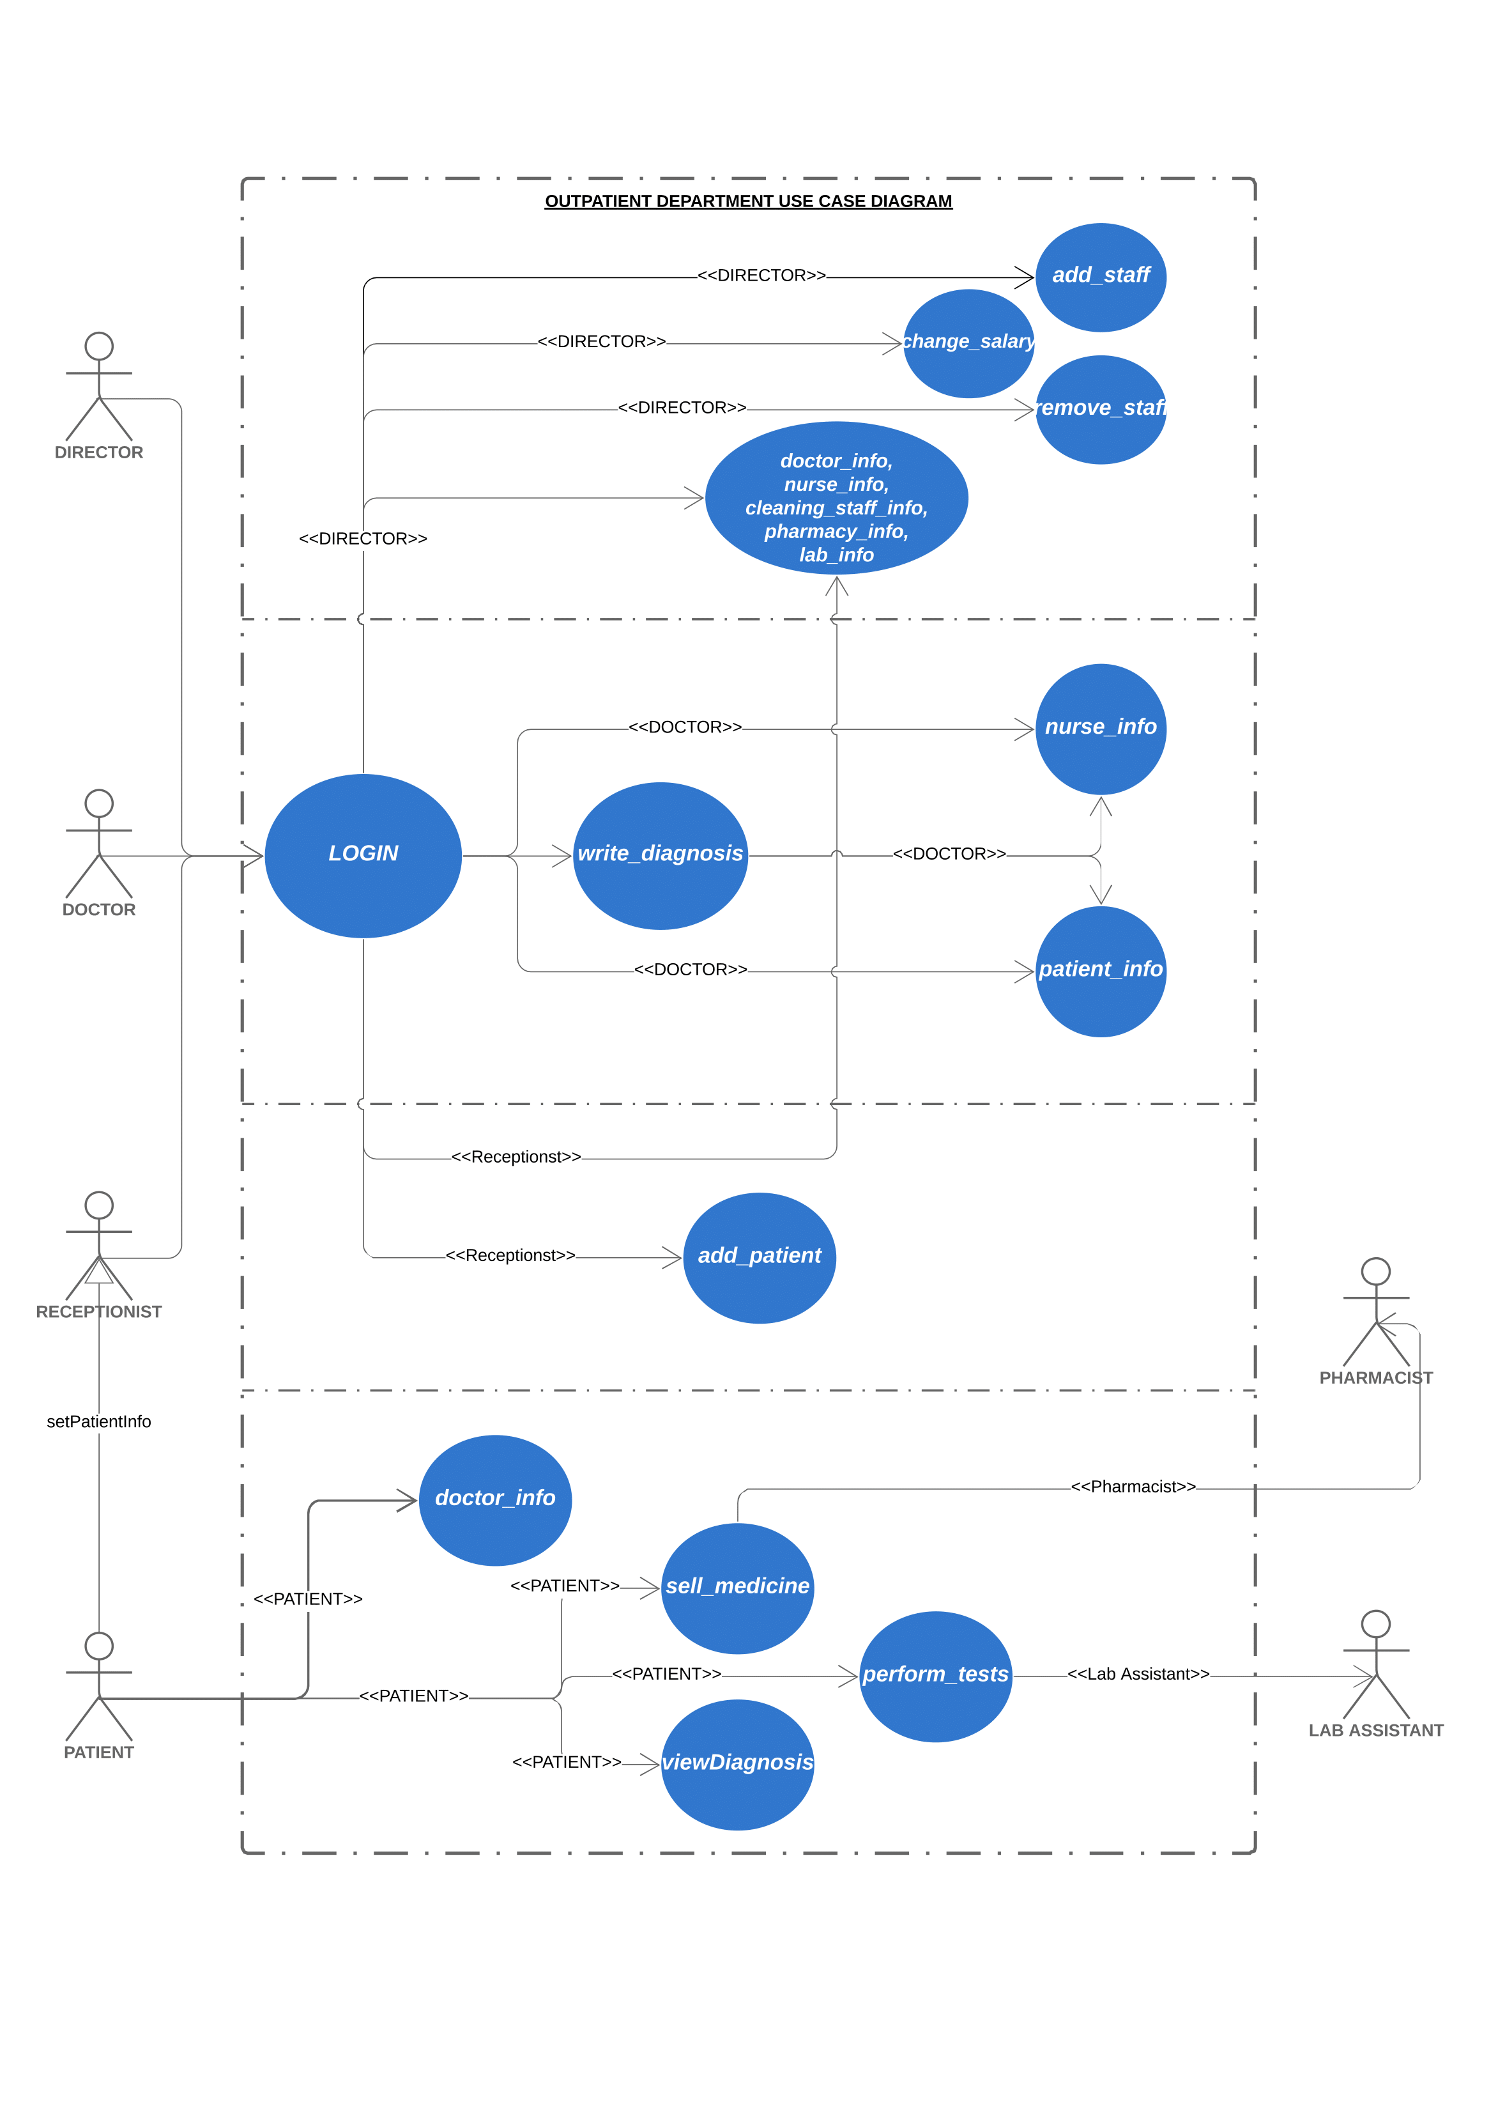

**Sequence Diagram** - A Sequence Diagram is an interaction diagram that emphasis the time ordering of messages; a collaboration diagram is an interaction diagram that emphasizes the structural organization of the objects that send and receive messages. Sequence diagrams and collaboration diagrams are isomorphic, meaning that you can take one and transform it into the other.

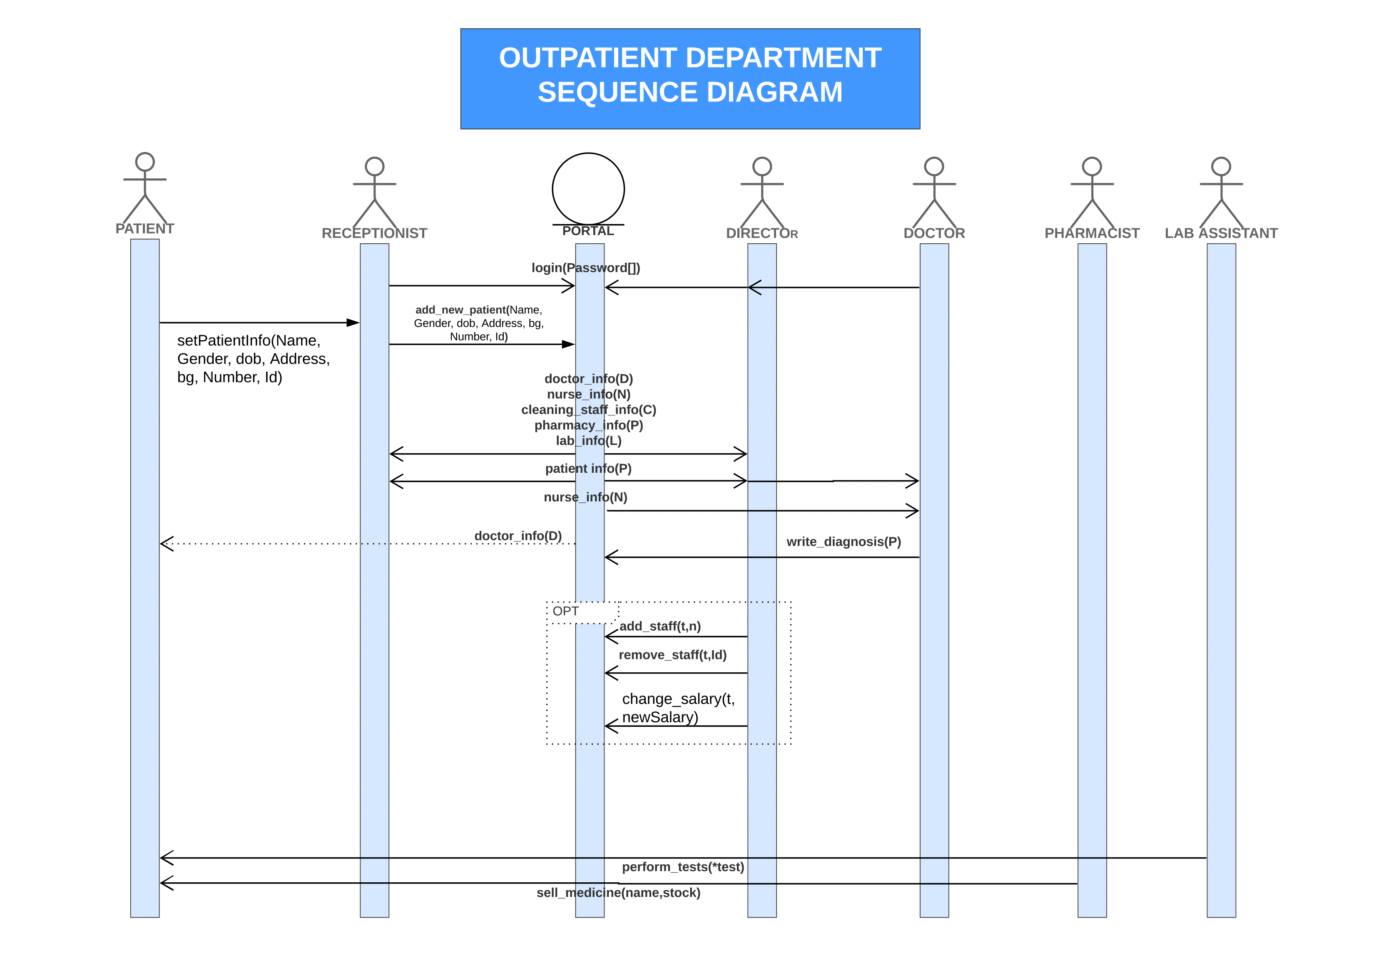

**State Machine Diagram** – The state diagram shows the states of an object and represents activities as arrows connecting the States.

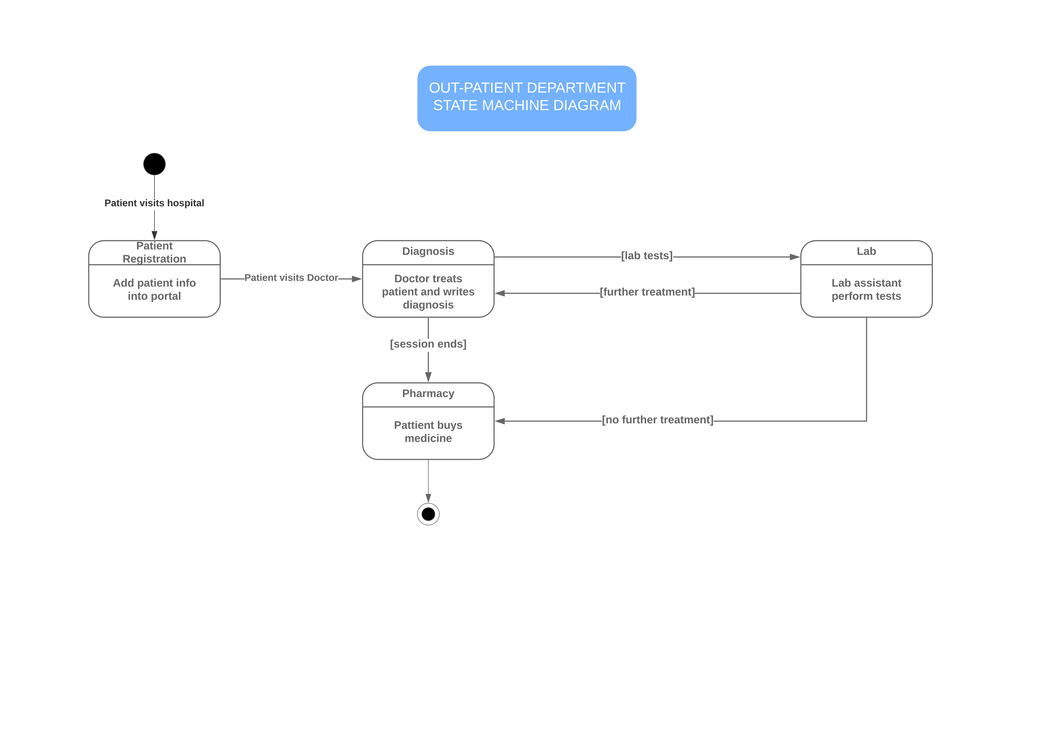

**Activity Diagram** – The activity diagram highlights the activities. Each activity is represented by a rounded rectangle-narrower and more oval-shaped than the state icon. An arrow represents the transition from one activity to the next. The activity diagram has a starting point represented by filled-in circle and an end point represented by bulls eye.

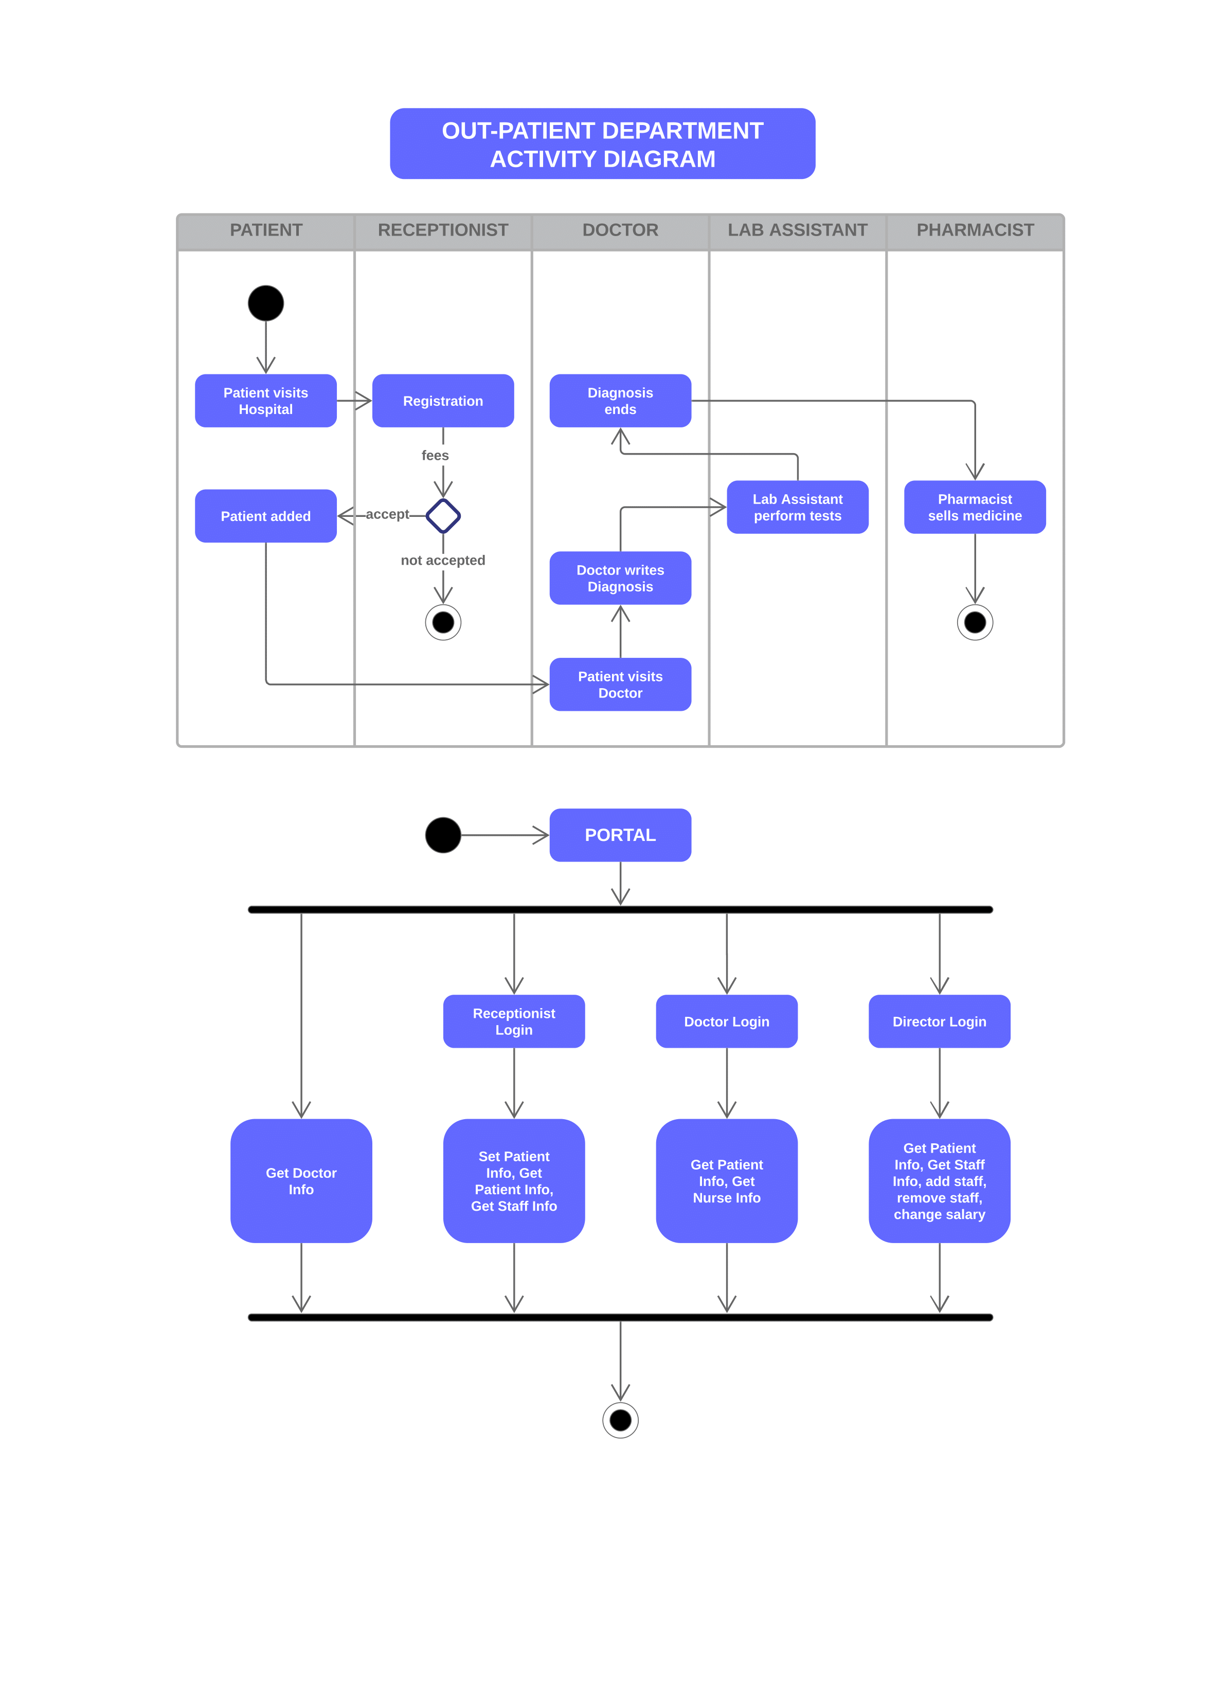

**5.SYSTEM IMPLEMENTATION**

**6.TESTING**

The purpose of testing is to discover errors. Testing is the process of trying to discover every conceivable fault or weakness in a work product. It is the process of exercising software with the intent of ensuring that the Software system meets its requirements and user expectations and does not fail in an unacceptable manner. There are various types of tests. Each test type addresses a specific testing requirement.

**TYPES OF TESTING**:

**Unit testing**:

Unit testing involves the design of test cases that validate that the internal program logic is functioning properly, and that program inputs produce valid outputs. All decision branches and internal code flow should be validated.

**Integration testing**:

Integration tests are designed to test integrated software components to determine if they actually run as one program. Integration tests demonstrate that although the components were individually satisfaction, as shown by successfully unit testing, the combination of components is correct and consistent. Integration testing is specifically aimed at exposing the problems that arise from the combination of components.

**Functional testing**:

Functional tests provide systematic demonstrations that functions tested are available as specified by the business and technical requirements, system documentation, and user manuals.

Functional testing is centered on the following items:

Valid Input : identified classes of valid input must be accepted.

Invalid Input : identified classes of invalid input must be rejected.

Functions : identified functions must be exercised.

Output : identified classes of application outputs must be exercised.

Systems/Procedures: interfacing systems or procedures must be invoked.

**System Testing**:

System testing ensures that the entire integrated software system meets requirements. It tests a configuration to ensure known and predictable results. An example of system testing is the configuration oriented system integration test. System testing is based on process descriptions and flows, emphasizing pre-driven process links and integration points.

**Test objectives**:

All field entries must work properly.

Pages must be activated from the identified link.

The entry screen, messages and responses must not be delayed.

**Features to be tested**:

Verify that the entries are of the correct format.

No duplicate entries should be allowed.

All links should take the user to the correct page.

**Test Results**:

All the test cases mentioned above passed successfully. No defects encountered.

**7.SAMPLE SCREENSHOTS**

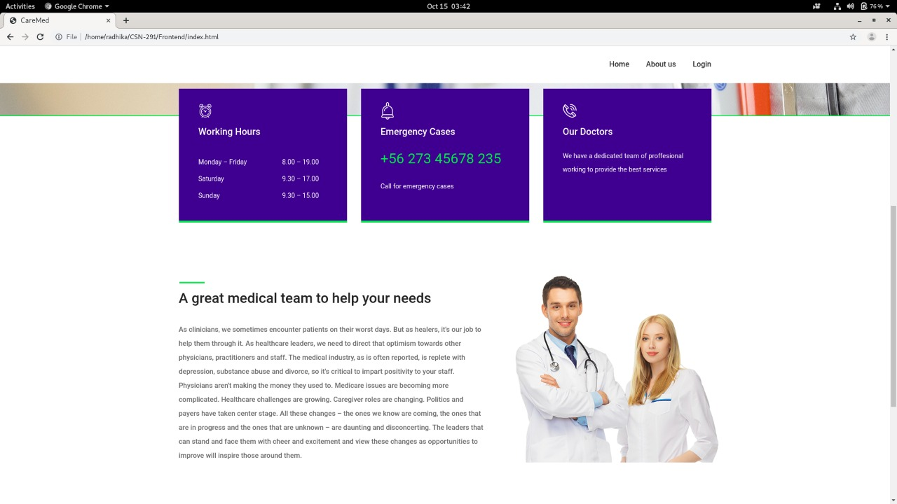 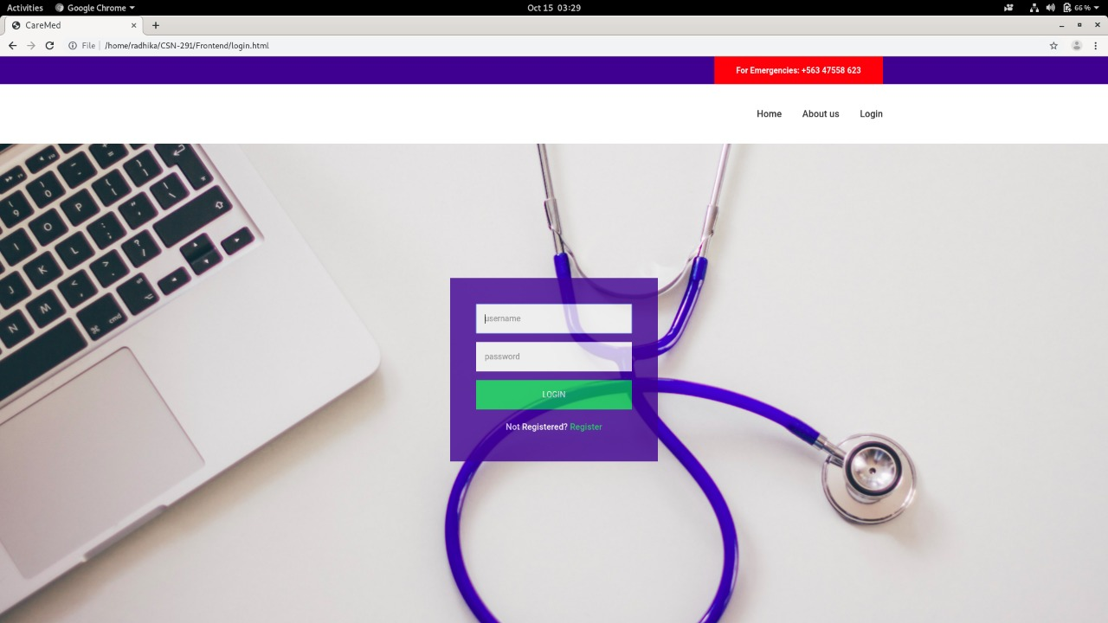 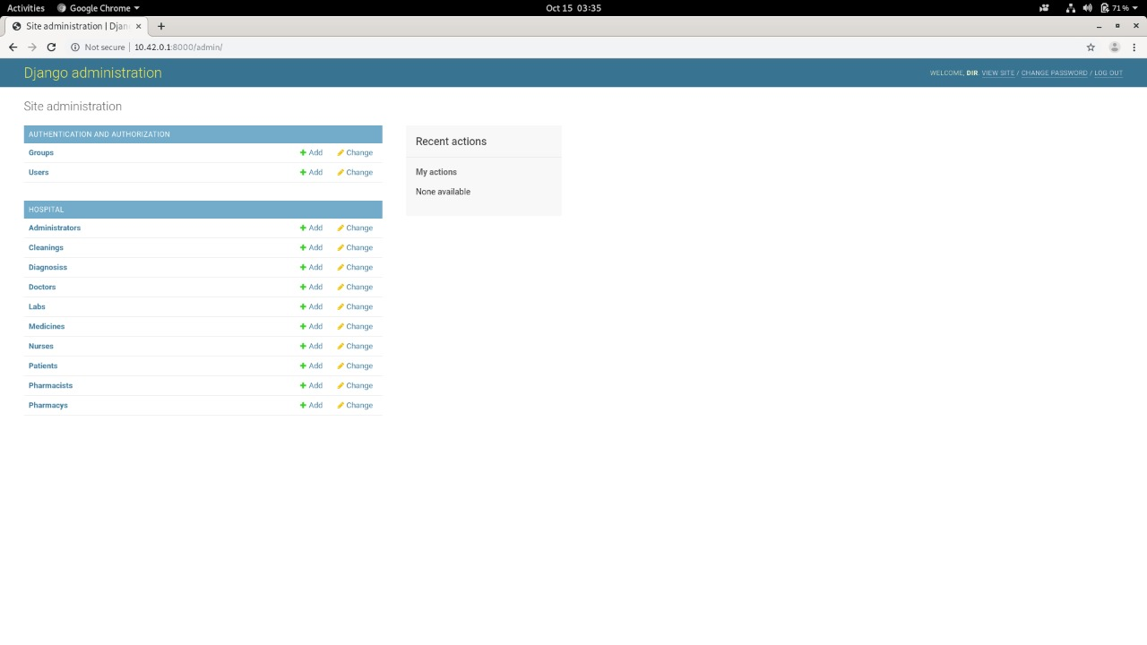 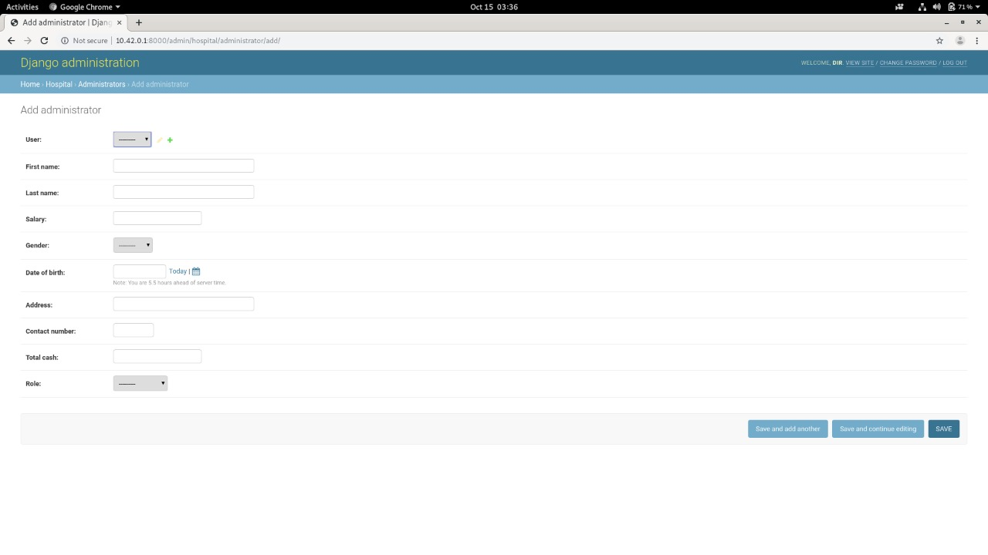 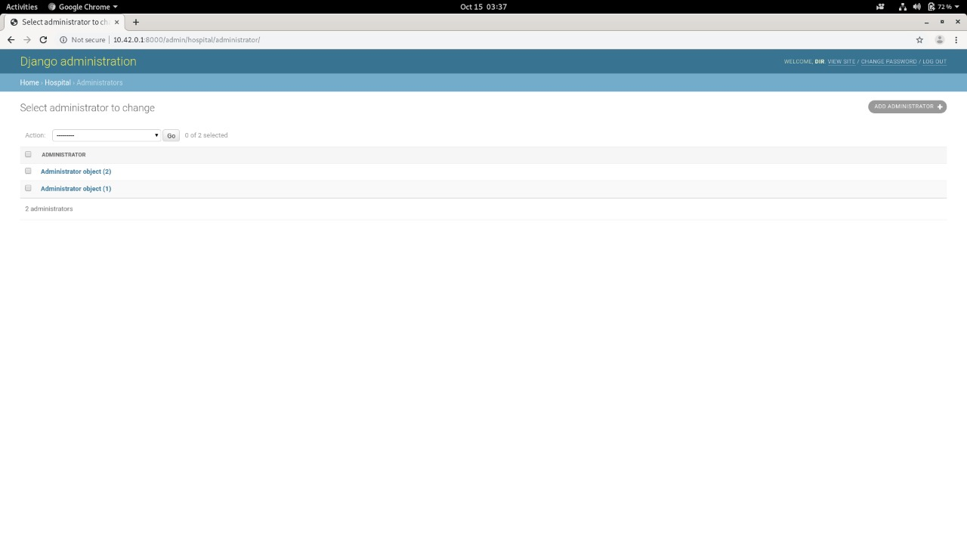 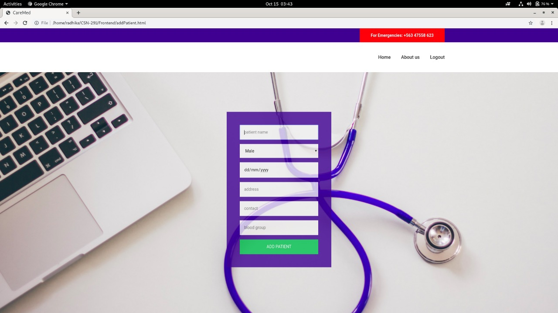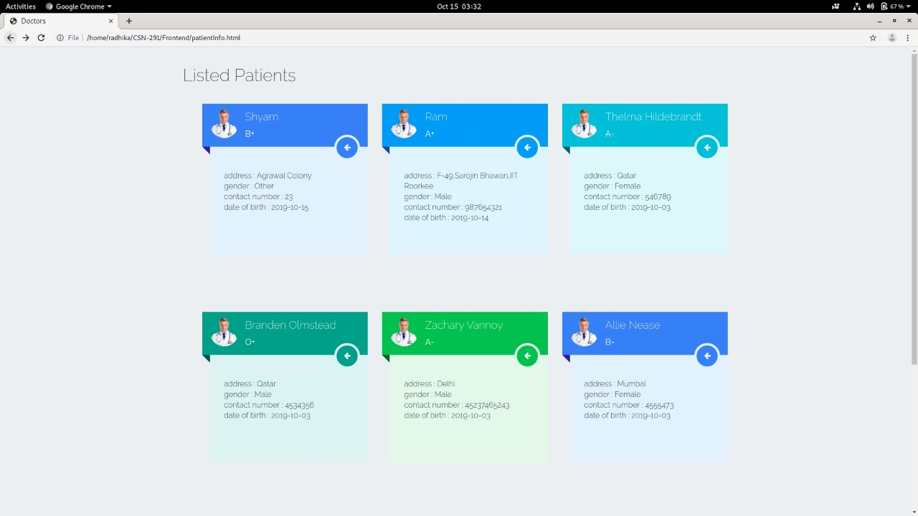 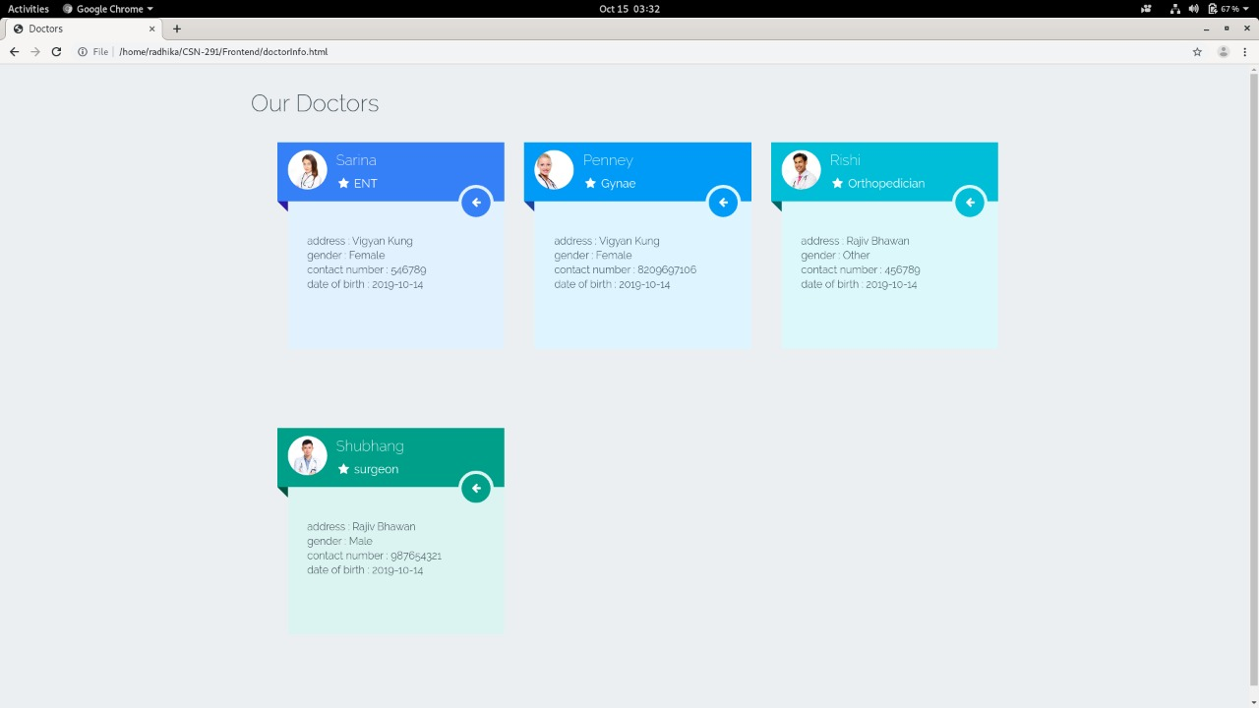 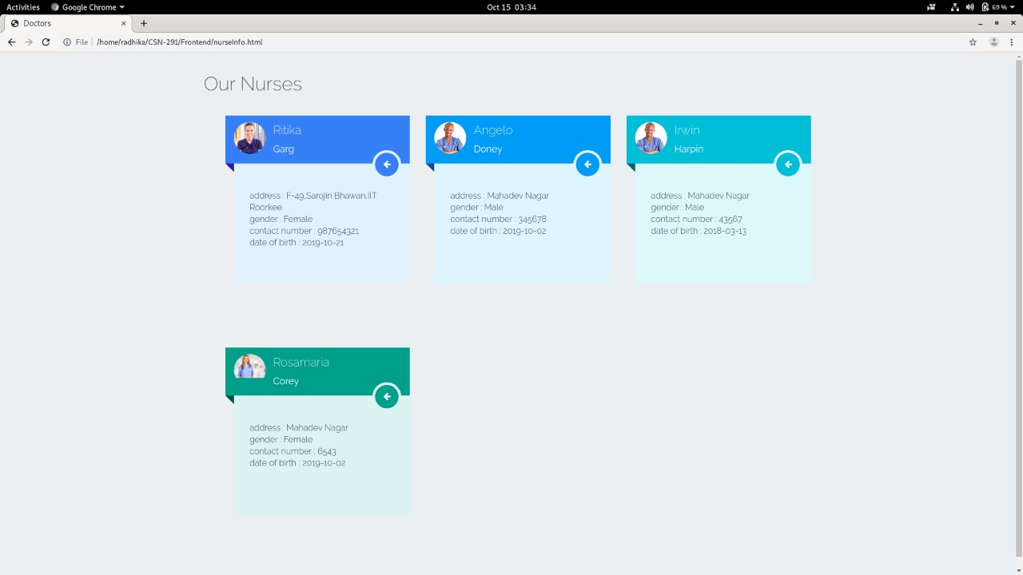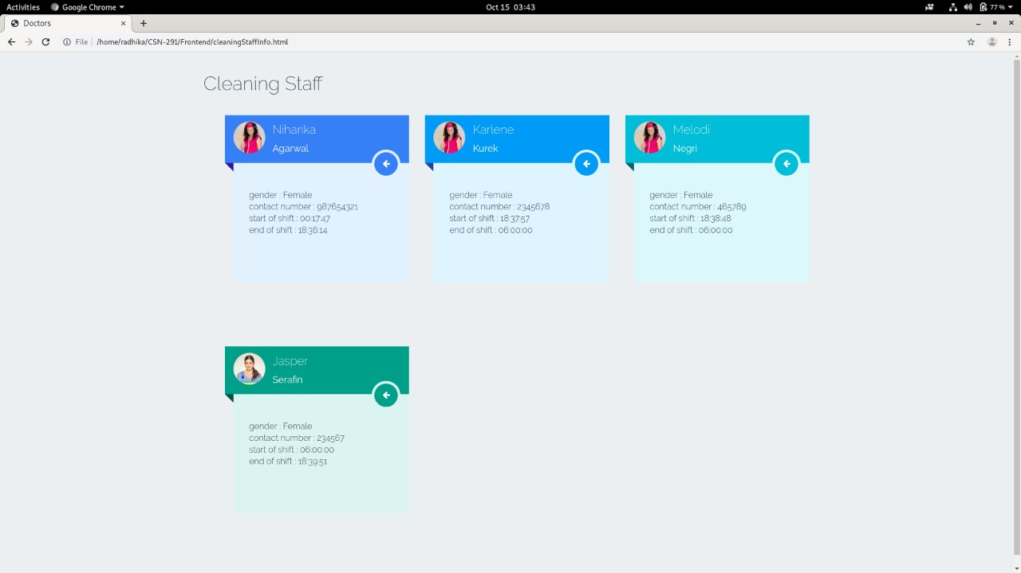 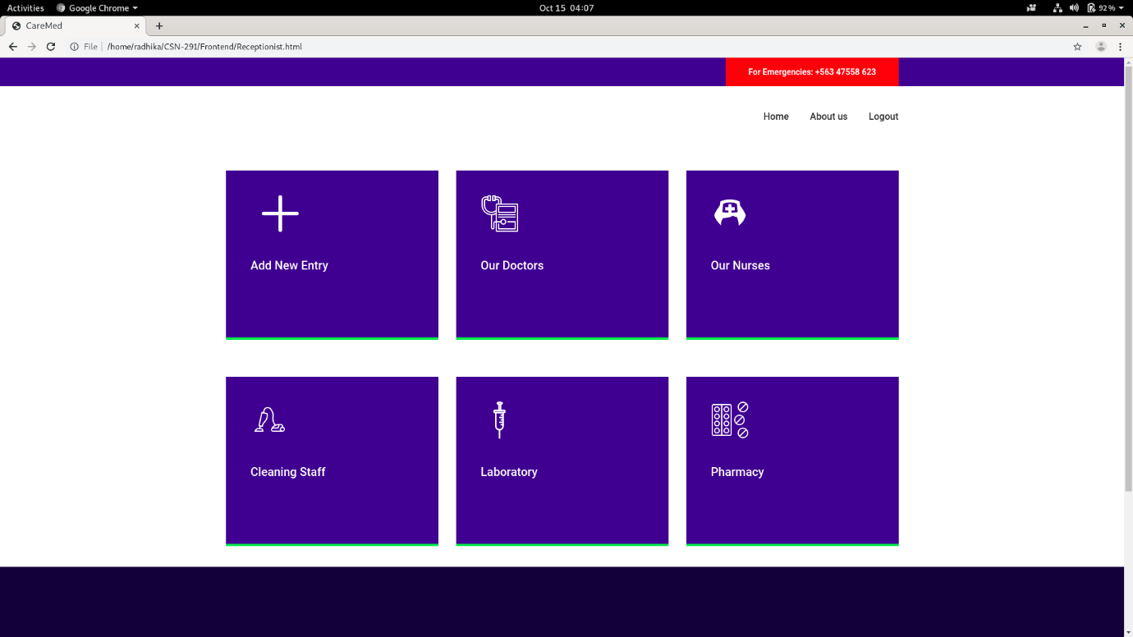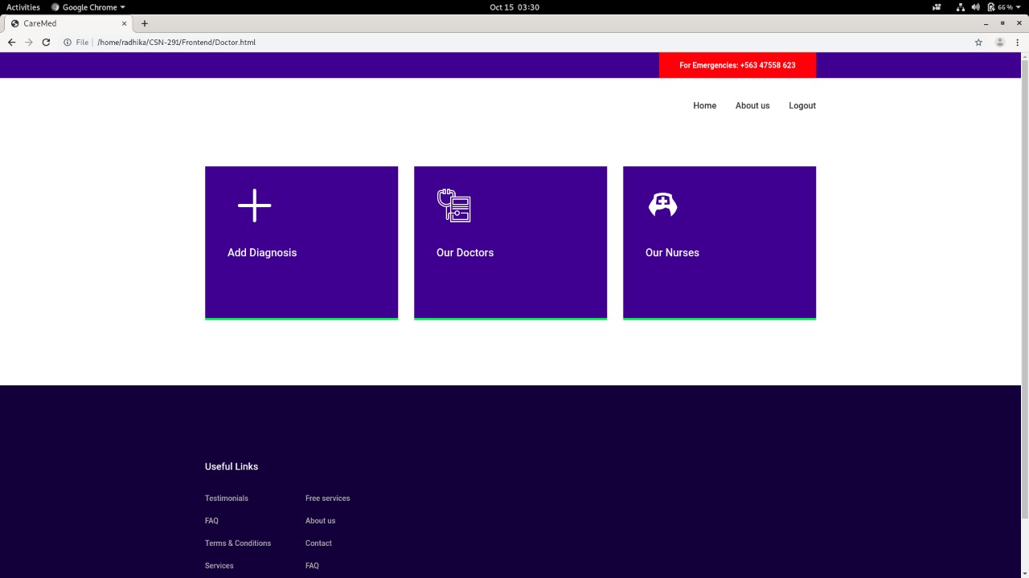 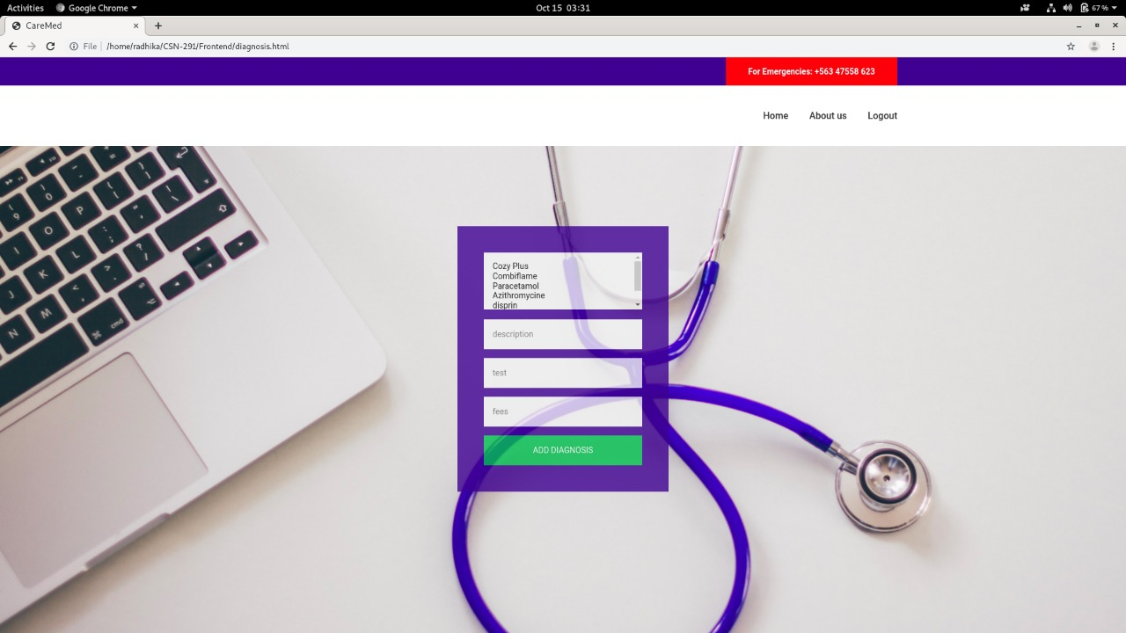 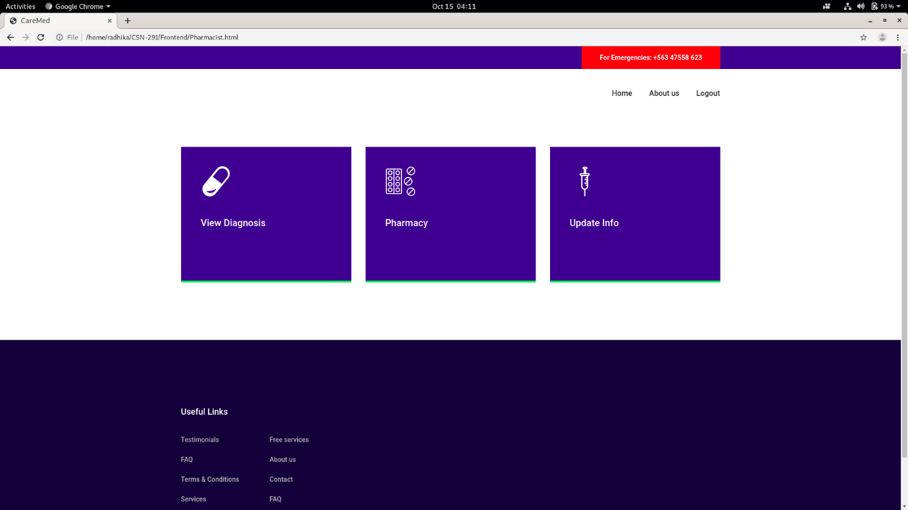 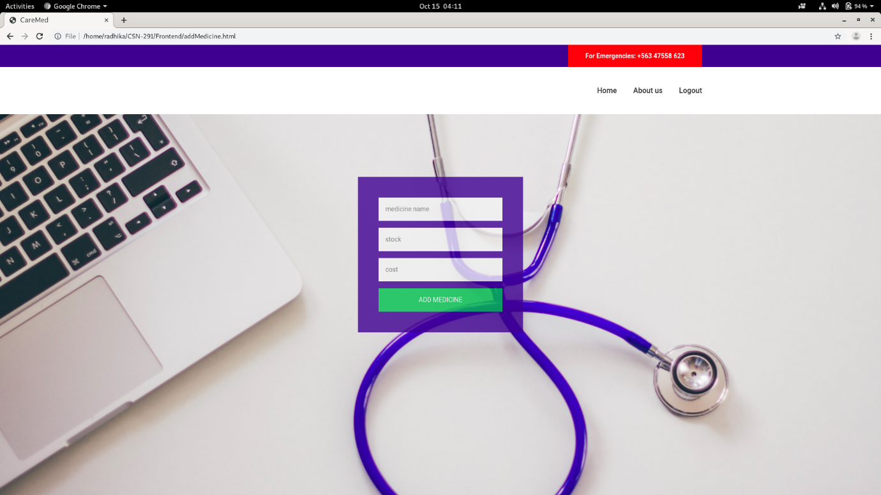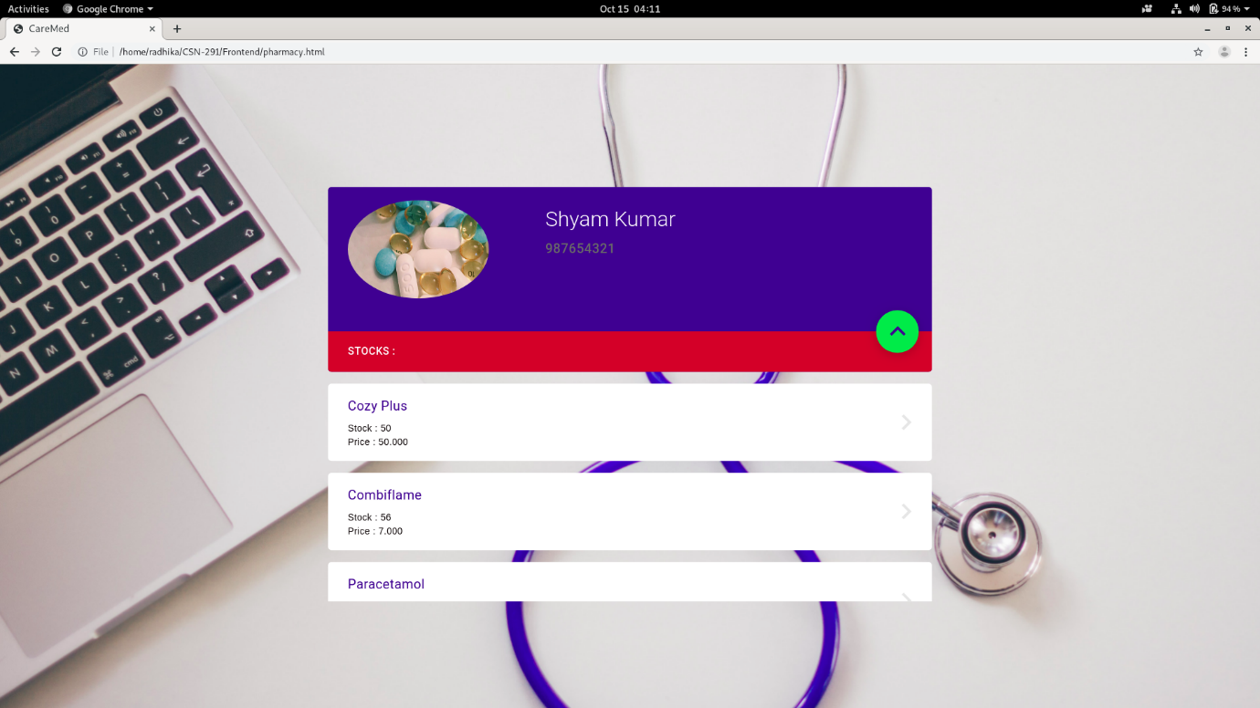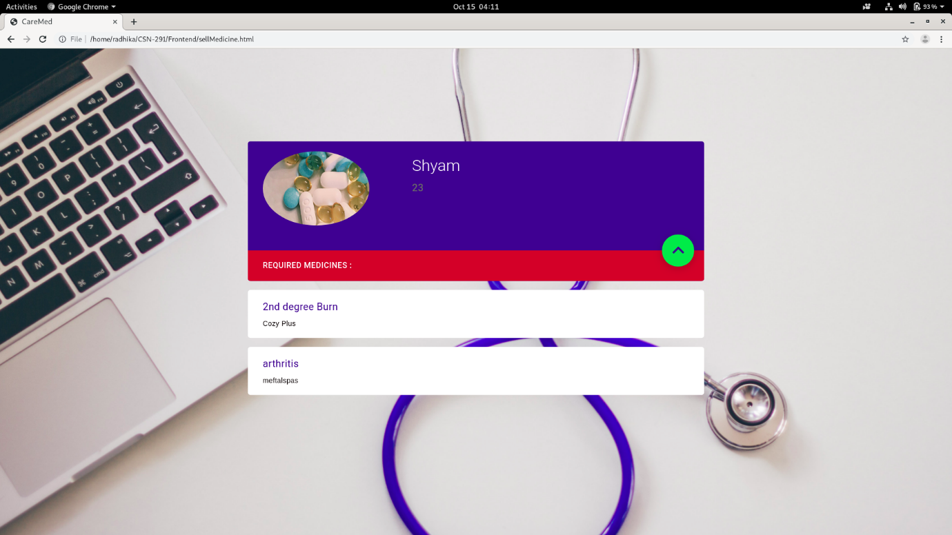 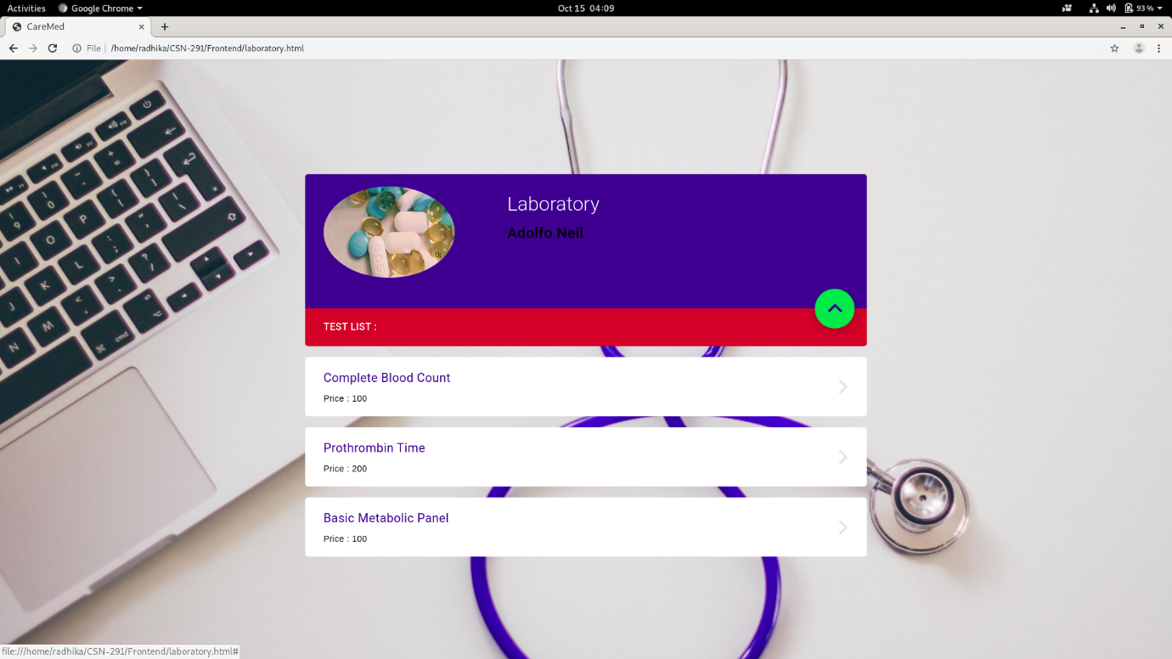

**8.CONCLUSION**

Since we are entering details of the patients electronically into the portal, data will be secured. Using this application we can retrieve patient’s details with a single click. Thus, processing information will be faster. It guarantees accurate maintenance of Patient details. It easily reduces the book keeping task and thus reduces the human effort and increases accuracy speed. Administration of the hospital could easily update any information into the portal through login and also get access to it. Doctor writes diagnosis into the portal, which makes patient easy to take the further step, to get a lab test or to buy the medicines.